**Practical No: 2**

<html>

<head>

<meta charset="UTF-8">

<meta name="viewport" content="width=device-width, initial-scale=1.0">

</head>

<body>

<form action="LifeCycle" method="get">

<input type="submit" value = "Click Here">

</form>

</body>

</html>

**Output:**

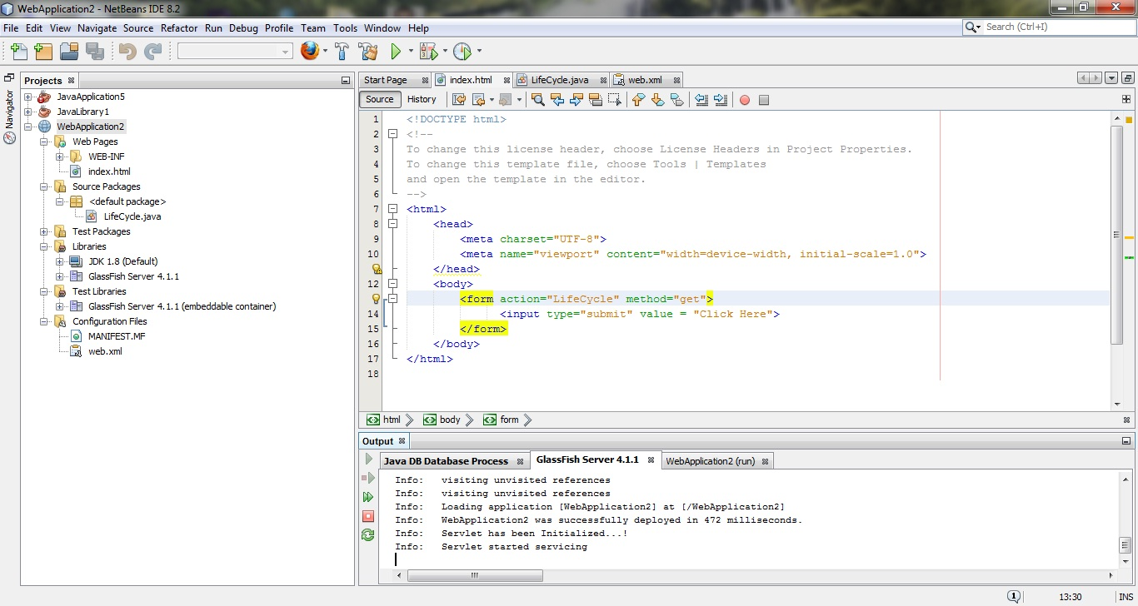

/*

* To change this license header, choose License Headers in Project Properties.

* To change this template file, choose Tools | Templates

* and open the template in the editor.

*/

import java.io.IOException;

import java.io.PrintWriter;

import javax.servlet.ServletException;

import javax.servlet.ServletRequest;

import javax.servlet.ServletResponse;

import javax.servlet.http.HttpServlet;

import javax.servlet.http.HttpServletRequest;

import javax.servlet.http.HttpServletResponse;

/**

*

* @author admin

*/

public class LifeCycle extends HttpServlet {

public void init() throws ServletException

{

System.out.println("Servlet has been Initialized...!");

}

public void service(ServletRequest req, ServletResponse res) throws ServletException,IOException

{

PrintWriter out = res.getWriter();

out.println("Servlet life cycle has three steps \n Initialise \n Service \n Destroy");

System.out.println("Servlet started servicing");

}

public void destroy()

{

System.out.println("Servlet has been destroyed..!");

}

}

**Output:**

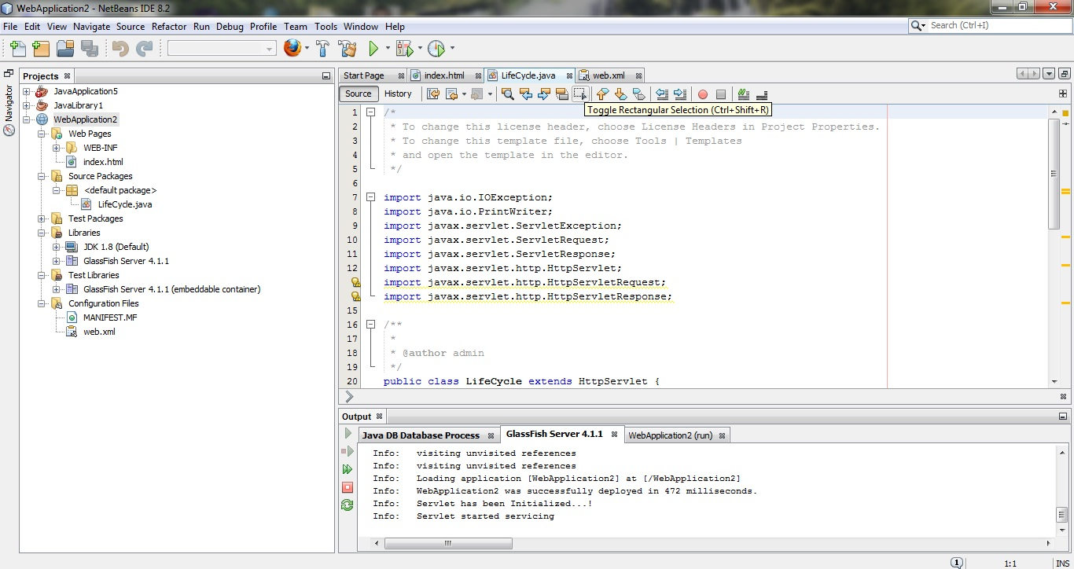

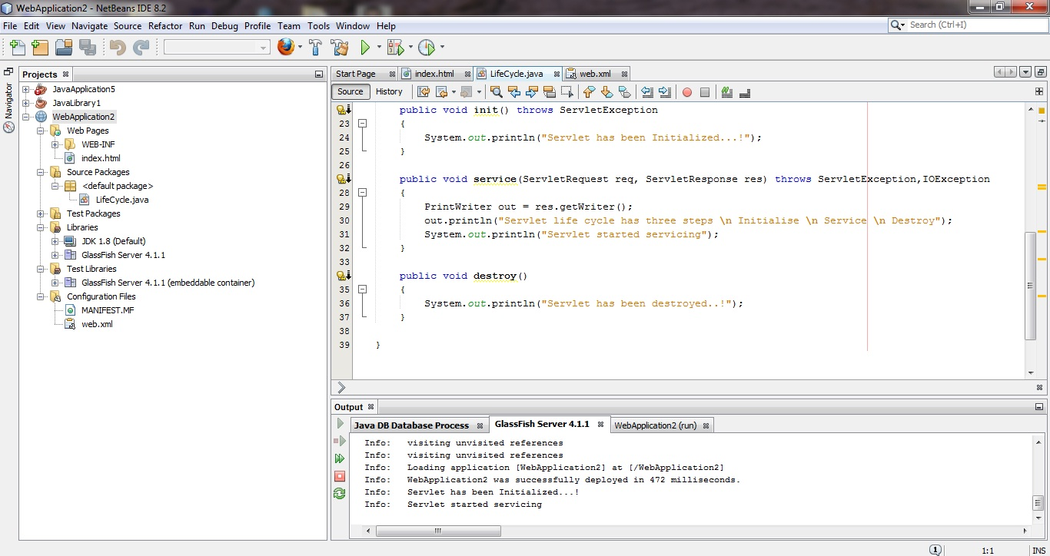

<?xml version="1.0" encoding="UTF-8"?>

<web-app version="3.1" xmlns="http://xmlns.jcp.org/xml/ns/javaee" xmlns:xsi="http://www.w3.org/2001/XMLSchema-instance" xsi:schemaLocation="http://xmlns.jcp.org/xml/ns/javaee http://xmlns.jcp.org/xml/ns/javaee/web-app_3_1.xsd">

<servlet>

<servlet-name>Demo</servlet-name>

<servlet-class>LifeCycle</servlet-class>

</servlet>

<servlet-mapping>

<servlet-name>Demo</servlet-name>

<url-pattern>/LifeCycle</url-pattern>

</servlet-mapping>

</web-app>

**Output:**

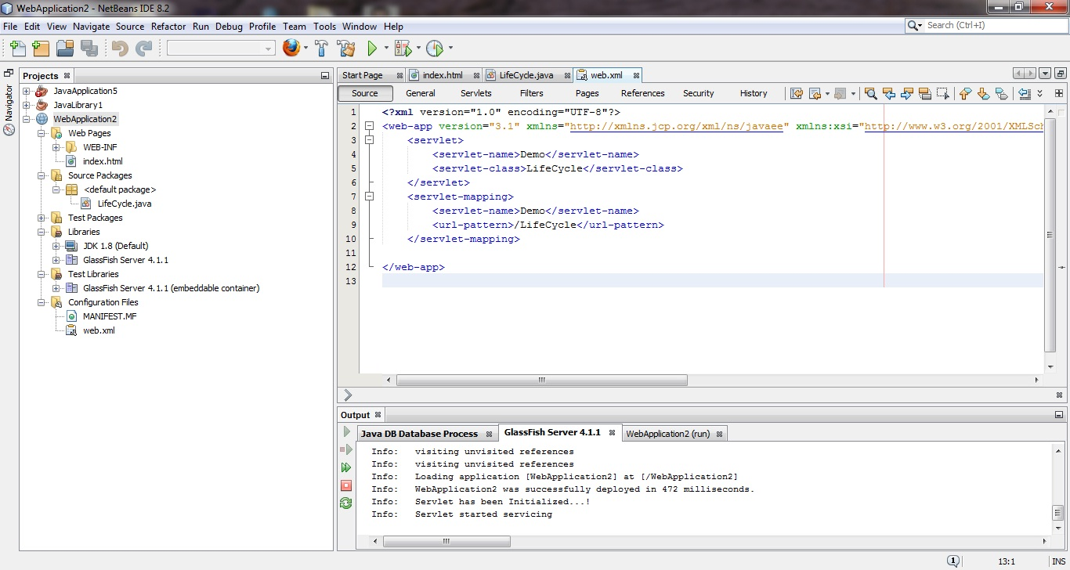

**Webpage Output:**

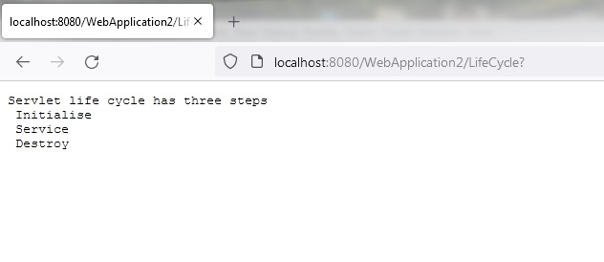**Top of Form**

Bottom of Form

Top of Form

Bottom of Form